How to Keep Your Horse Cool This Summer
Drs. Foster & Smith Educational Staff
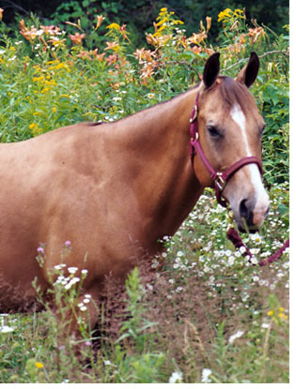 | 
 | Summer is the perfect time to own a horse. The show and competition circuit is in full swing. Farms and ranches teem with activity. Long, sunlit days lend themselves to lazy trail rides. But summer's hot weather and high humidity pose serious health risks for most horses and ponies. However, there are simple ways to help keep your horse cool and healthy.
shelter from the sun
Searing heat and sweltering humidity can be dangerous for horses. Every year, numerous cases of colic, dehydration, and respiratory distress are attributed to warmer summer weather. Worse, potentially fatal heatstroke or exhaustion causes a few deaths each summer. Thankfully, however, responsible horse care and vigilance when the temperatures rise is all most horses need to cruise through summer in comfort. To help your horse beat the heat, keep the following tips in mind:
Water - use a suitable water bucket to frequently offer fresh, cool, clean water. Average size work horses can consume over 25 gallons of water per day when the temperature is above 70°F. Also, keep water troughs and stock tanks clean and free from insects to promote consumption.
Shade - offer an escape from the sun while in the pasture with a run-in shed. In addition, turnout your horse as early as possible in the morning to help avoid the heat. To combat early morning mosquitoes and flies, use suitable repellents, fly masks, and sheets.
Electrolytes - replenish salt loss during excessive sweating with a suitable electrolyte supplement, especially with work horses or when the combined temperature and humidity exceeds 140°F. Serious electrolyte loss causes fatigue, muscle cramps, colic, and more.
Ventilation - cool your horse while he rests in the barn with appropriate stable fans. If possible, leave barn doors and windows open and install misting fans near each stall. Choose a run-in shed with an open-end design to promote airflow.
Baths - sponge cold water over your horse, especially down the large blood vessels under the belly and neck and inside the legs. In extreme heat, spray a 50/50 mixture of rubbing alcohol and cold water over his body to aid sweating.
Fodder - feed quality hay, especially as warm weather slows grass growth and pasture quality declines. Hay offers energy, which your horse needs to help regulate his body temperature and power his natural cooling processes.
Coat Care - clip your horse's coat and keep his mane and tail trimmed. Apply a zinc oxide sunscreen to pink noses to help prevent sunburn. Use shampoos with added sunscreen to help protect against UV rays and sunburns.
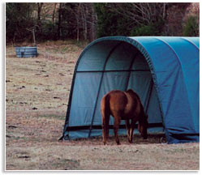
signs of heatstroke
A common misconception is that hot summer weather only affects work or show horses. This is untrue. While active horses are more susceptible to a rise in temperature, extreme heat can quickly take its toll on any horse. In fact, heatstroke can occur whether your horse is plowing a field, standing in a stuffy stall, or traveling in a trailer.
Heatstroke occurs when your horse is unable to rid his body of excess heat. Your horse's body has a natural cooling process. However, extreme heat and humidity can overpower your horse's ability to cool himself. To compensate, the body redistributes blood flow closer to the skin, which aids cooling. However, this mechanism causes internal organs and the brain to receive less oxygen. Add excessive sweating into the mix, which causes a loss of fluids and electrolytes, and the results can be disastrous. Signs of heatstroke - also known as heat stress or heat exhaustion - include:
Elevated Respiratory Rate - between 40 to 50 breaths per minute, shallow breathing, and breathing that remains elevated after two minutes of rest
Elevated Heart Rate - a pulse of more than 80 beats per minute that doesn't slow down after two minutes of rest
Increased or Absence of Sweating - full-body sweating or, worse, if your horse stops sweating entirely
Elevated Temperature - a rectal temperature of 103°F or higher
Lethargy - signs of depression, disinterest in food, stumbling or collapsing
Heatstroke is a serious condition. Severe cases of heatstroke lead to collapse, seizures, or loss of your horse. If you suspect your horse is suffering from heatstroke, immediately take measures to help cool him. Contact your veterinarian if symptoms persist or his condition worsens. To help cool your horse:
Stop Activity - cease workouts, rides, or farm work immediately
Bathe Immediately - douse him with cold water or a water/alcohol mix
Offer Water - allow your horse to drink as much water as he desires
Find Shade - get your horse out of direct sunlight and into the shade
Fan Your Horse - stand your horse beneath a stable fan or in a breezy area
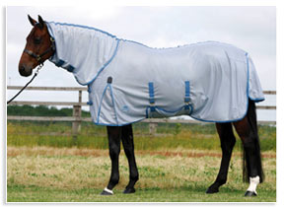
maintain overall health
Your horse's ability to beat the summer heat depends, in part, on his overall health. Sick or injured equines may not have the energy necessary to naturally cool themselves. Similarly, internal parasites can rob your horse of his health and make him even more susceptible to heat exhaustion or stress. Furthermore, your horse can expend large amounts of energy fleeing the swarm of biting insects that usually accompanies summer weather and further expose himself to the elements.
As such, it is important to keep your horse current on his deworming schedule. Suitable insect sprays, fly sheets and masks, and barn and stable traps can also help protect your horse from flies, mosquitoes, and gnats. Together with diligent horse care, you and your horse should be set to enjoy the endless fun of summer.

